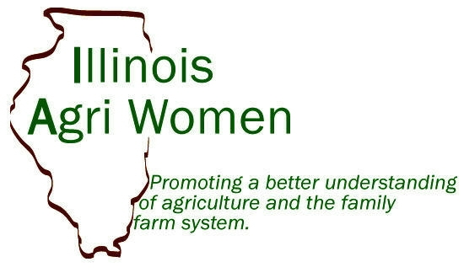
Application for:
□ Illinois Agri Women Hall of Fame
□X Outstanding Illinois Woman Farmer
□ Illinois Agri Business Award
Deadline for all applications is July 1, 2014.
Preferred method of nomination: email to __abenttree@aol.com_________
Winners and nominators will be notified by IAW board member.
Awardsresented at Illinois State Fair on Ag Day (1st Tuesday of State Fair in Springfield, IL)
Nominator’s contact information:
Bob Aherin, PhD & Professor
Agricultural Safety & Health Program Leader & AgrAbility Program Director
University of Illinois
1304 West Pennsylvania Avenue
Urbana, IL 61802
Phone: 217-333-9417
Email: raherin@illinois.edu

Nominee’s name, address, phone, and/or title
Brenda Besse
Brierwood Farms
7785 Cordova Road
Erie, IL 61250
Phone: 309-314-3884
Email: brierwoodfarms@frontier.com

On the following page, nominate your candidate using 400 words or less:
Nominee: Brenda Besse
For the award: Outstanding Illinois Woman Farmer
Presented by: Bob Aherin
(Narrative and support of candidate: Brenda has made significant contributions to agriculture. She is co-owner/operator of Brierwood farms which is a dairy of registered Brown Swiss cows located near Hillsdale, Illinois in Whiteside County. Brenda was born and raised on this farm. Growing up she was active in 4-H and sports. She attended and graduated from Northern Illinois University and was a college basketball standout and avid golfer. In 1981 after graduating from college and returning to the farm she lost her right leg above the knee during a fall harvest combine accident. While this type of accident could have a significant negative impact on many people’s lives it had just the opposite effect on Brenda. She was determined not to let this tragic event significantly affect her determination and enthusiasm to have a high quality life and a positive impact on those she associates with. Brenda’s went on to show her cows for many years at the state fair and other major dairy show events in the Midwest winning numerous awards.
She began playing competition golf on the national Amputee Golf Association Tour in 1991. She has competed in 97 AGA tournaments, and has been the ladies champion 86 times. She has played in 16 PGA and LPGA Pro-Am golf events with many professional golfers. She assists in organizing the John Dolan Golf Challenge, which is a charity event that has raised over 3 million dollars in the last 17 years for the Rehabilitation Institute of Chicago.
She has also conducted educational sessions on farm safety at nearly 30 farm safety day camps for children and parents.
Brenda’s biggest contribution to agriculture has been her work for the past 16 years with the Illinois AgrAbility Unlimited Program. This is a program that provides a variety of services to assist farm people with disabilities to continue as farmers and being as productive as they can. She coordinates much of the program’s work in the rural communities in the northern half of Illinois. This includes making initial contacts with disabled farmers, supporting and coordinating the work of more than 40 volunteer AgrAbility local ambassadors and helping with fund raising to support the program. She has conducted training for occupational and physical therapist to enhance their skills and abilities regarding how to meet the needs of disabled farmers. She has been featured in two national videos about the AgrAbility program and its benefits to farmers.

Scoring for Illinois Agri Women Hall of Fame
The IAW Board/assigned committee will use an evaluation system, allotting from 1 to 10 points for each quality described by the person(s) making the nomination. Total points possible—50

EVALUATION: The qualities upon which to base your selection include (but are not limited to) the following:

Enthusiasm
Visionary leadership
Displays courage
Exhibits ability to produce intended effects
Encourages and helps develop talents and skills of others
______ Involvement in the community
Total points

Scoring for Outstanding Illinois Woman Farmer
The IAW Board/assigned committee will use an evaluation system, allotting from 1 to 10 points for each quality described by the person(s) making the nomination. Total points possible—30

EVALUATION: The qualities upon which to base your selection include (but are not limited to) the following:

Major decision maker for a farm operation/contributions to a farm operation
Community involvement
Displays courage
______ Willingness to help others
Total points

Scoring for Illinois Agri Women Production Award
The IAW Board/assigned committee will use an evaluation system, allotting from 1 to 10 points for each quality described by the person(s) making the nomination. Total points possible—40

EVALUATION: The qualities upon which to base your selection include (but are not limited to) the following:

Involvement in agribusiness or education
Impact on clientele or students
Community involvement
Displays courage
Total points

