West Virginia AgrAbility would like to share a series of webinars and informational fact sheets in observance of National Farm Safety & Health Week, September 20-26.

This year the theme for National Farm Safety & Health Week is “Ag Safety is not just a slogan, it’s a lifestyle.” The daily webinars are hosted by the AgriSafe Network from 12-1 pm CST Monday – Friday and registration is available at www.agrisafe.org/national-farm-safety-health-week-2015.

Informational fact sheets are available on the Facebook page of the International Society for Agricultural Safety and Health (ISASH) at https://www.facebook.com/ISASH.
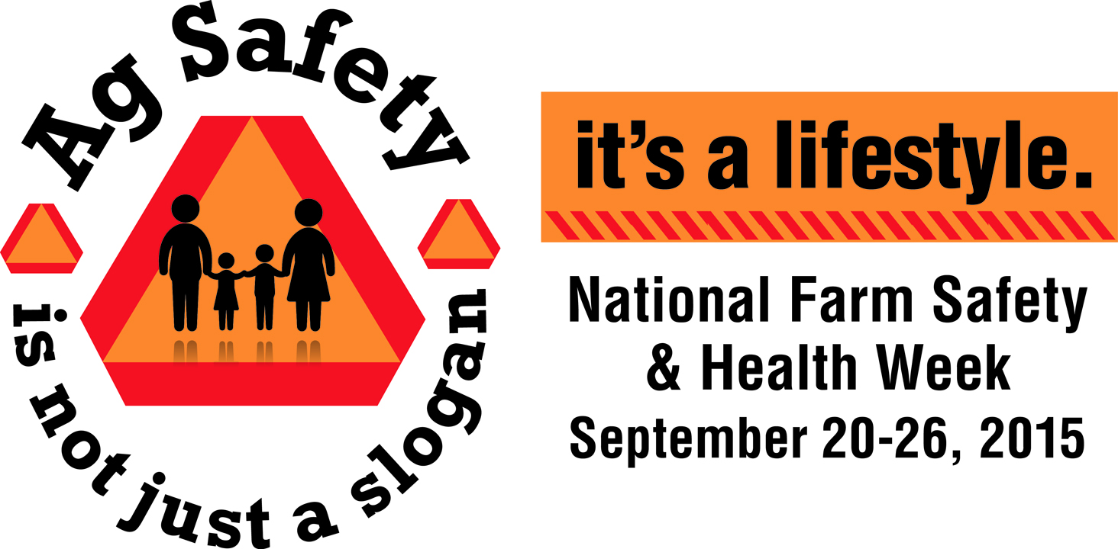
This year’s topics are:
Sunday – Aging Farmers
Monday – Rural Roadway
Tuesday – Confined Spaces in
Agriculture
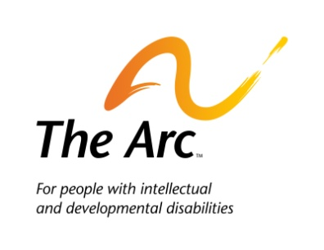
Wednesday – Children’s Topics
Thursday – Health
Friday – Tractor Safety
Saturday – ATV Safety

The theme “Ag Safety is not just a slogan, it’s a lifestyle” reminds local and rural communities that agriculture is one of the most dangerous occupations in the U.S. and farm injuries and fatalities are preventable through education. The most recent data from the U.S. Department of Labor indicates that in 2013 farming accounted for 500 fatalities, or 23.2 deaths per 100,000 workers.

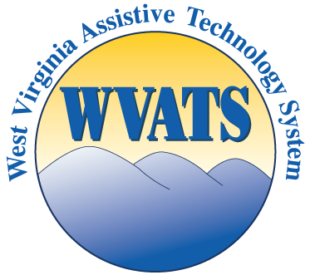
Each year since 1944, the third week of September has been recognized as National Farm Safety and Health Week. This recognition has been an annual promotion initiated by the National Safety Council and has been proclaimed as such by each sitting U.S. President since Franklin D. Roosevelt signed the first document.

As we recognize National Farm Safety & Health Week, please join us in promoting safe and healthy practices on our farms as many producers enter the harvest season.

For more information, contact: Inetta Fluharty, WV AgrAbility Program Specialist at (304) 771-8747 or ifluharty@wvagrability.org. Additional information about WV AgrAbility is available at www.wvagrability.org.

